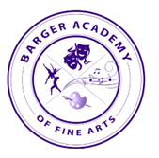
Barger Academy of Fine Arts 2023-2024
Second Grade Supply List
Please do NOT write names on all items. ONLY label the water bottle, headphones, and scissors.

Reusable Water Bottle  ~16 oz or smaller  ~spill-proof lid with straw | 30 Ticonderoga Pre-Sharpened Pencils and 1 pencil pouch | Over-Ear Headphones | 2 Composition Notebooks, Black & White
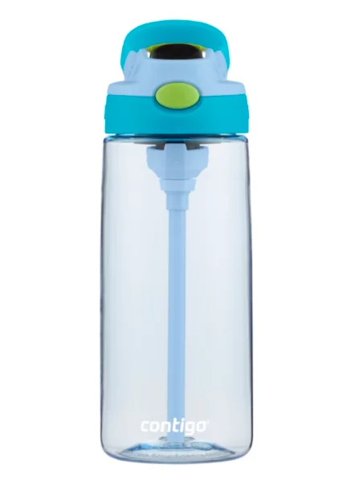 | 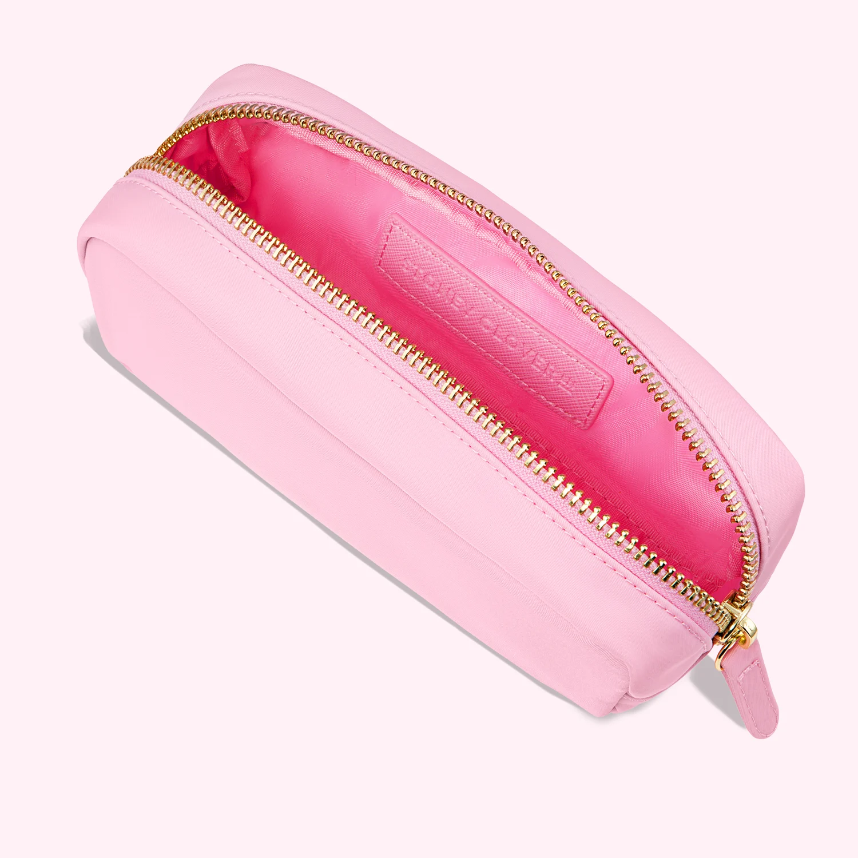 | 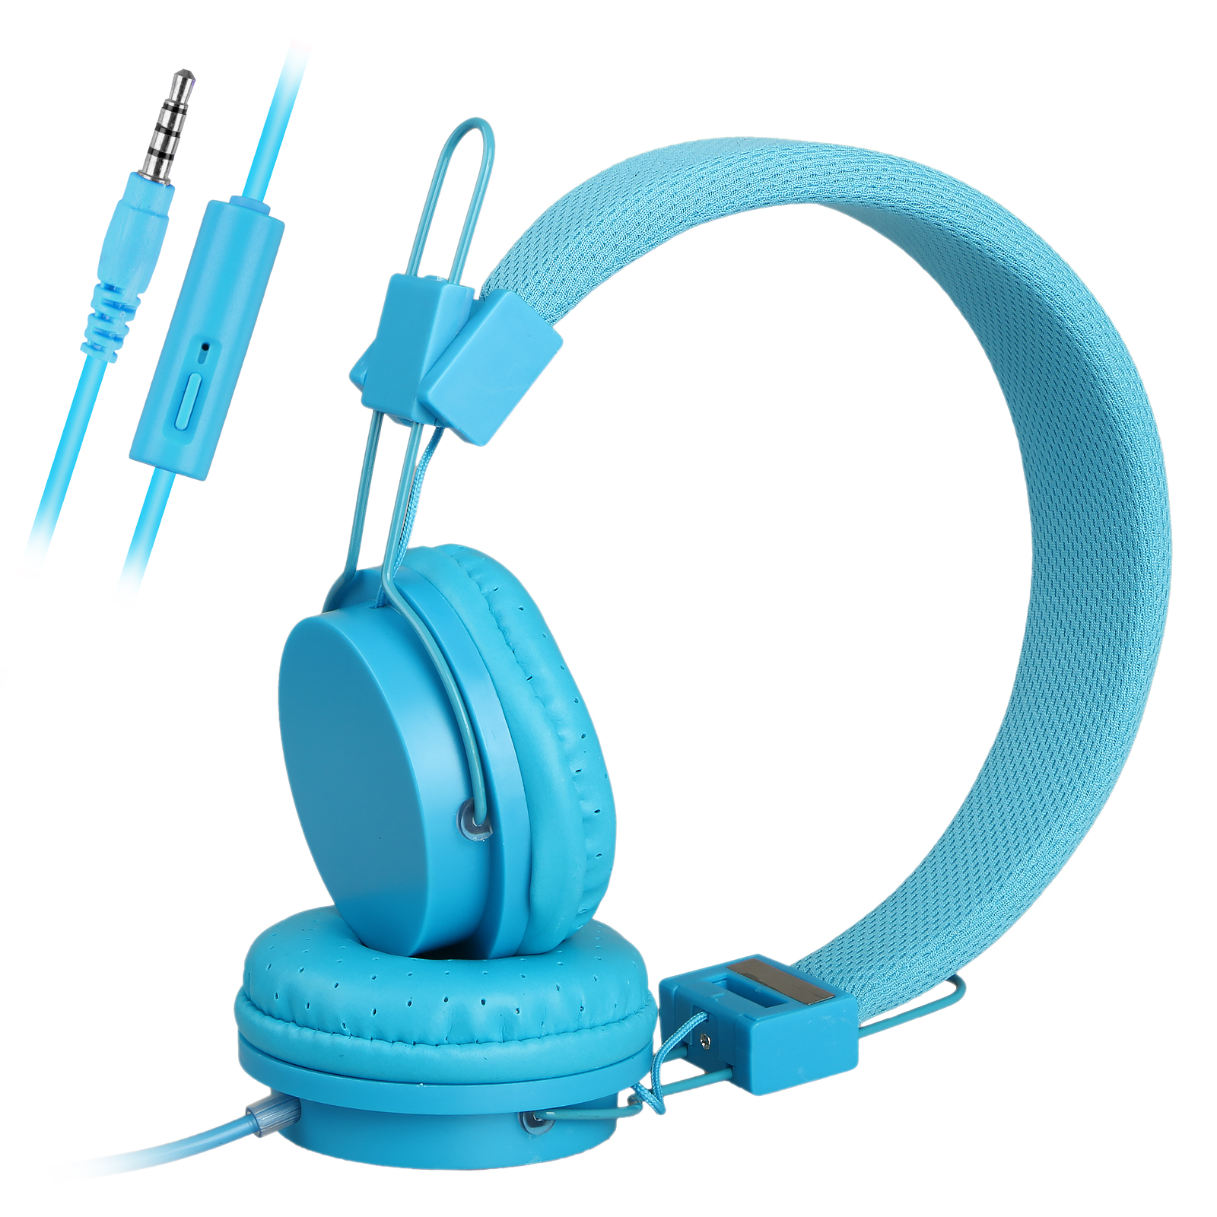 | 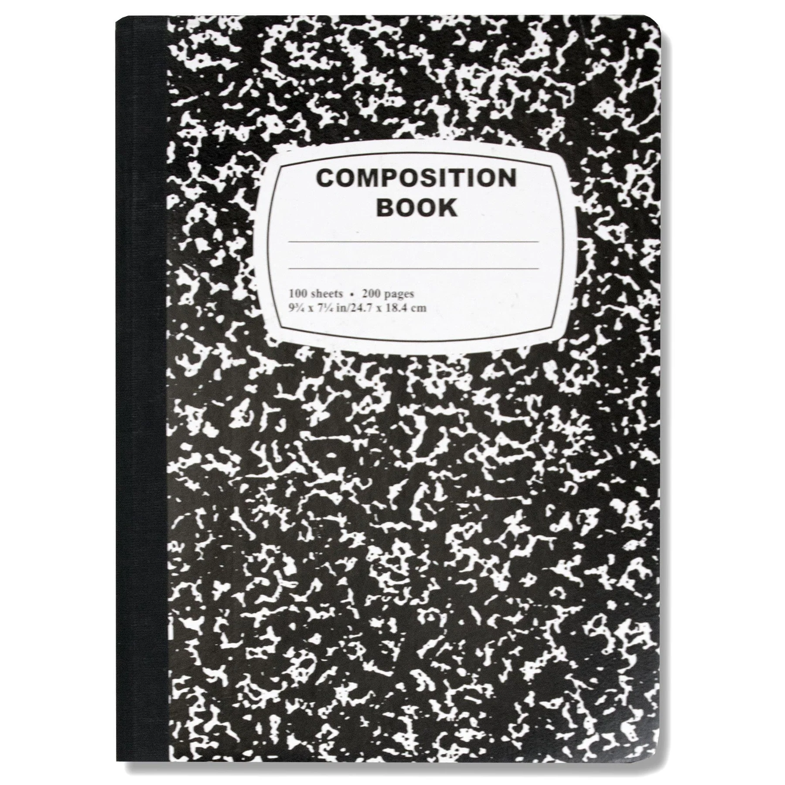
2 boxes of 24 ct Crayola Crayons | 3 Bar Pencil Erasers | 3 Solid Color Plastic Folders with pockets & brads | 1 pack of 4 ct. Elmer’s glue sticks
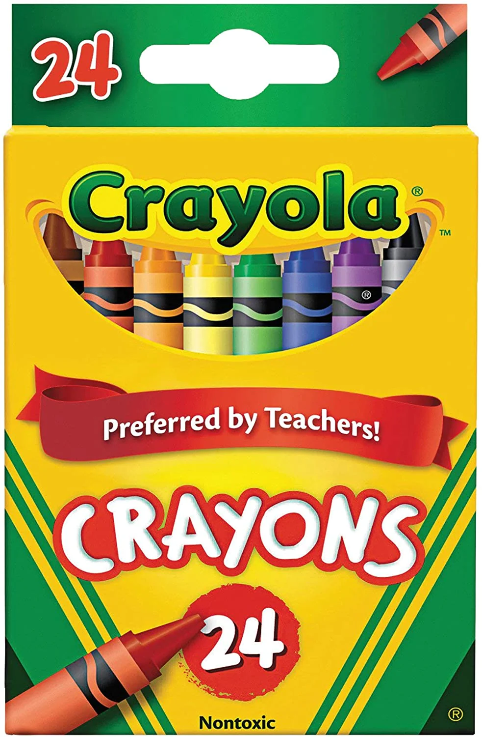 | 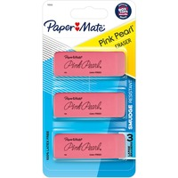 | 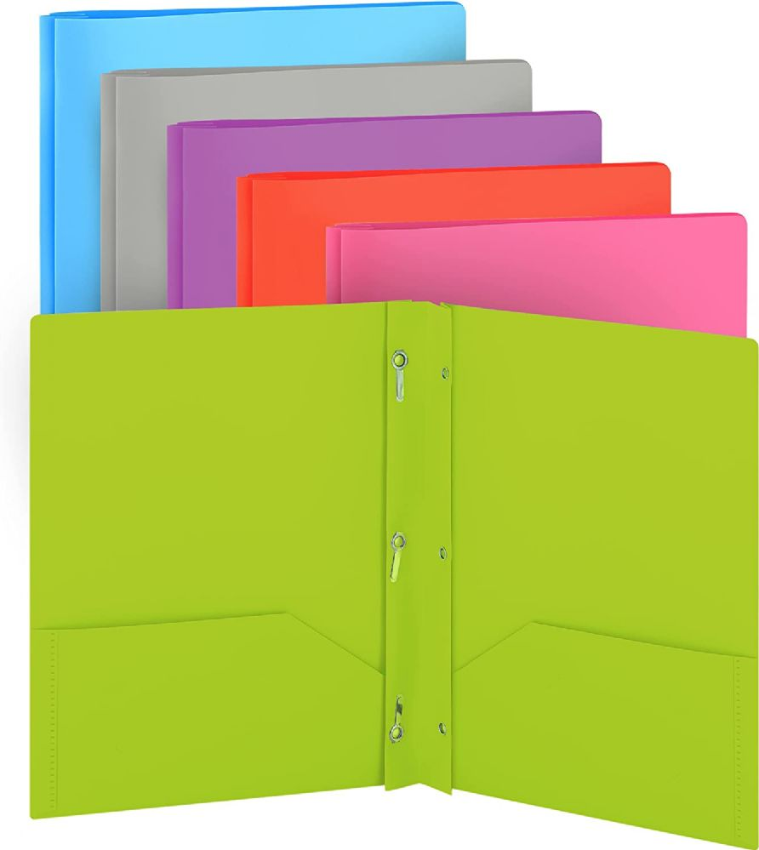 | 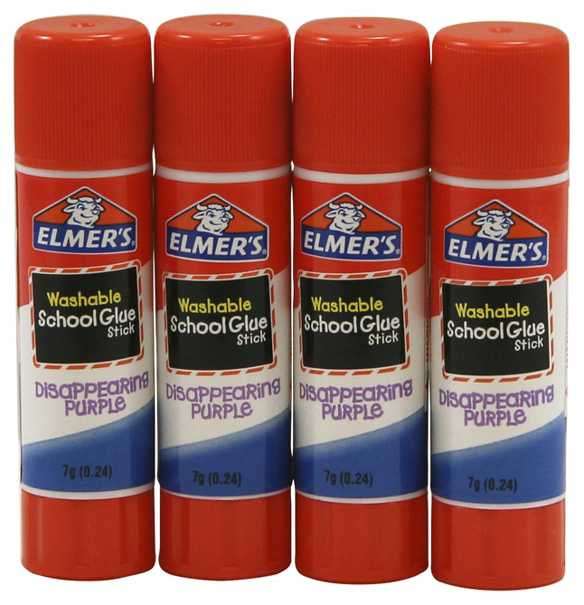
4 packs of 4 ct Thin, Black Expo Markers | 2 Packs of Post-it Notes, any size | Student Scissors | Kleenex or Puffs Facial Tissue
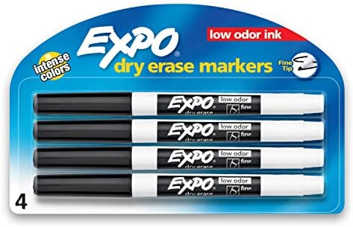 |  | 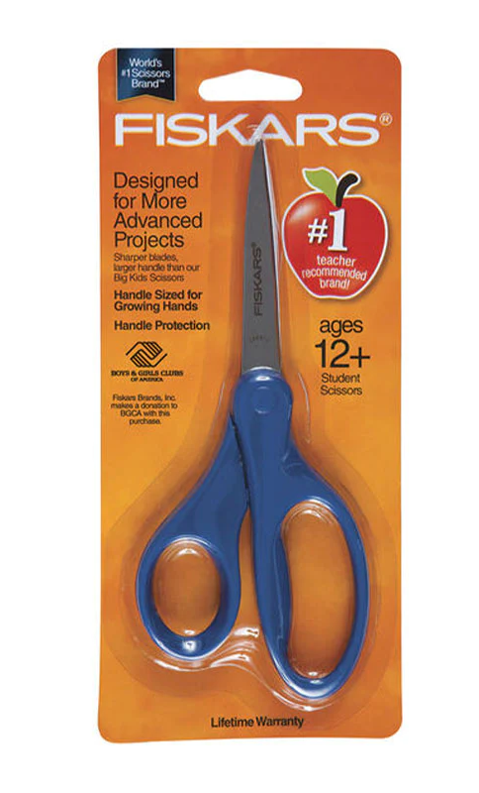 | 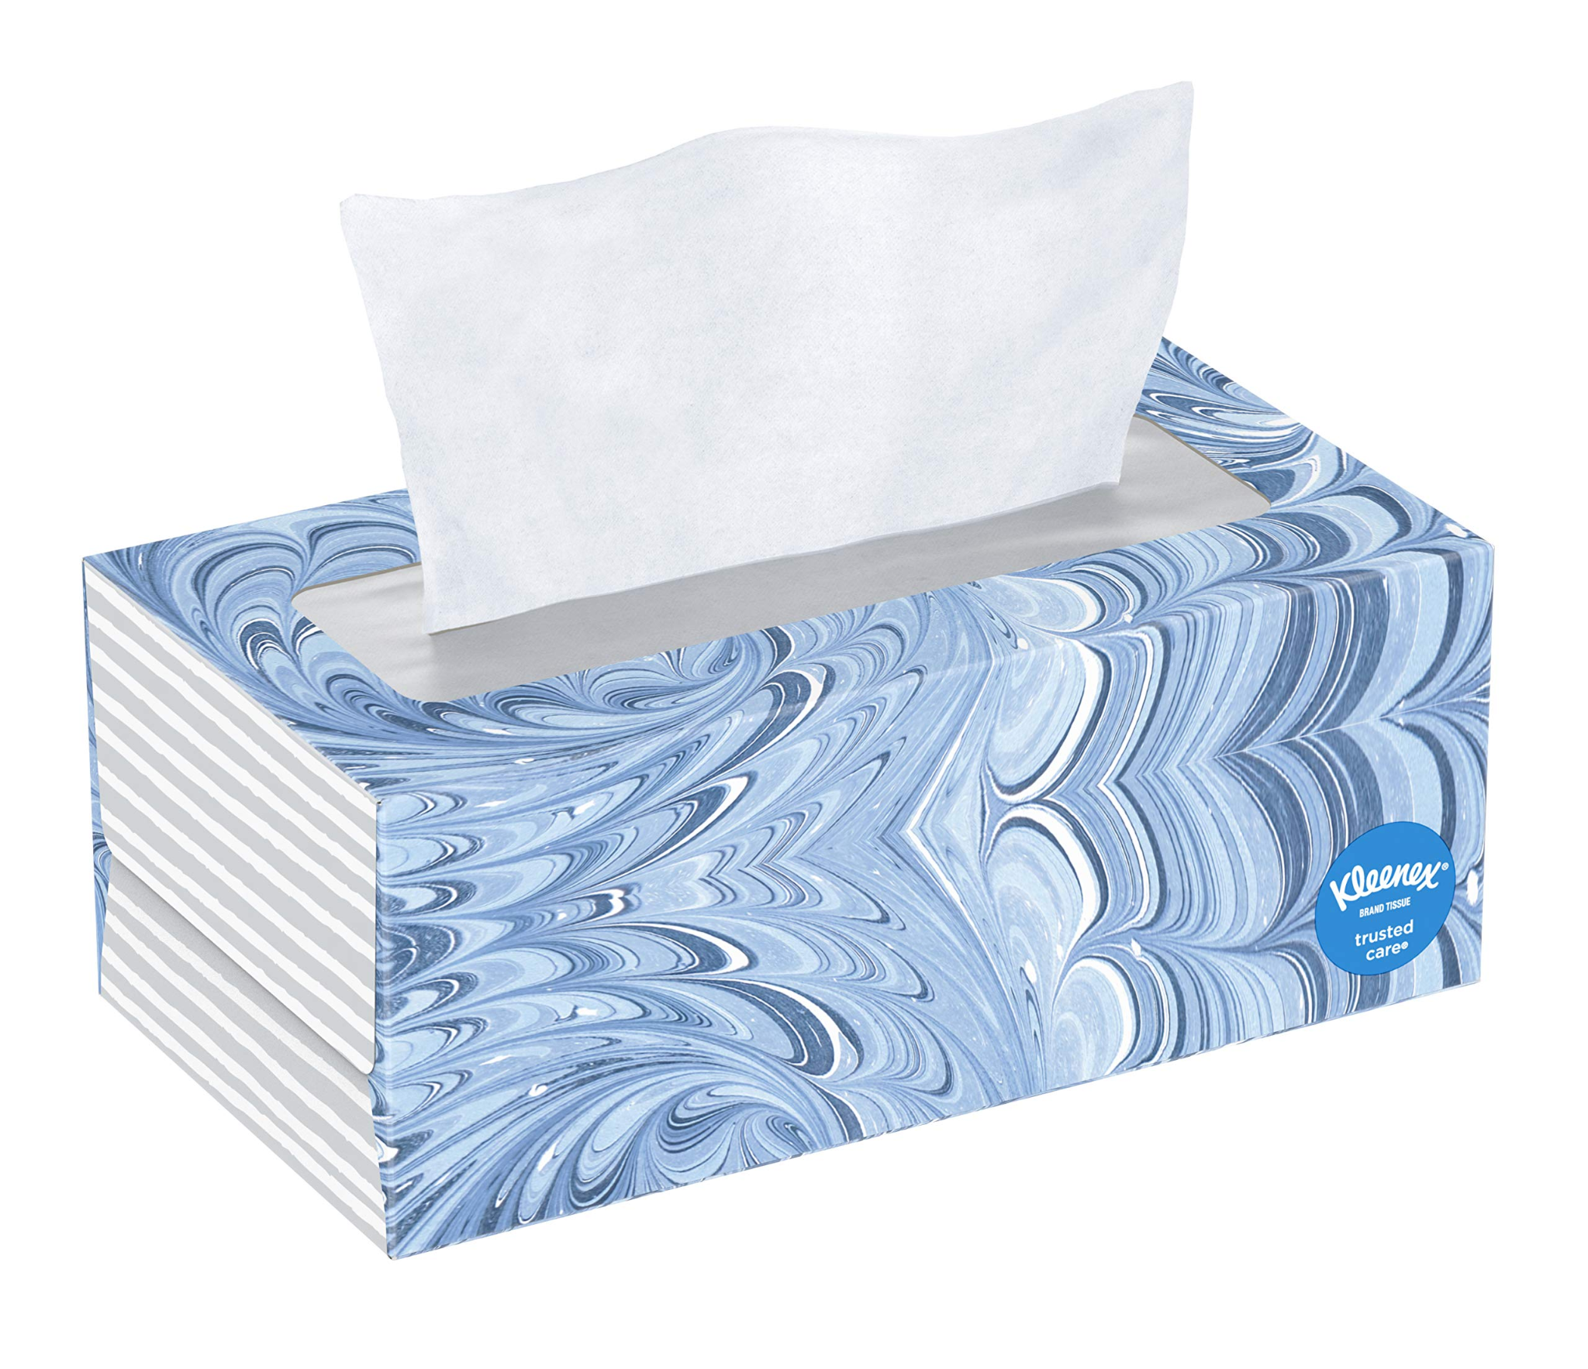
Clorox or Lysol Disinfectant Wipes | 2 Rolls of Paper Towel | 2 boxes of Zipper Bags,  1 Gallon & 1 Snack Size | 1 pack White Cardstock
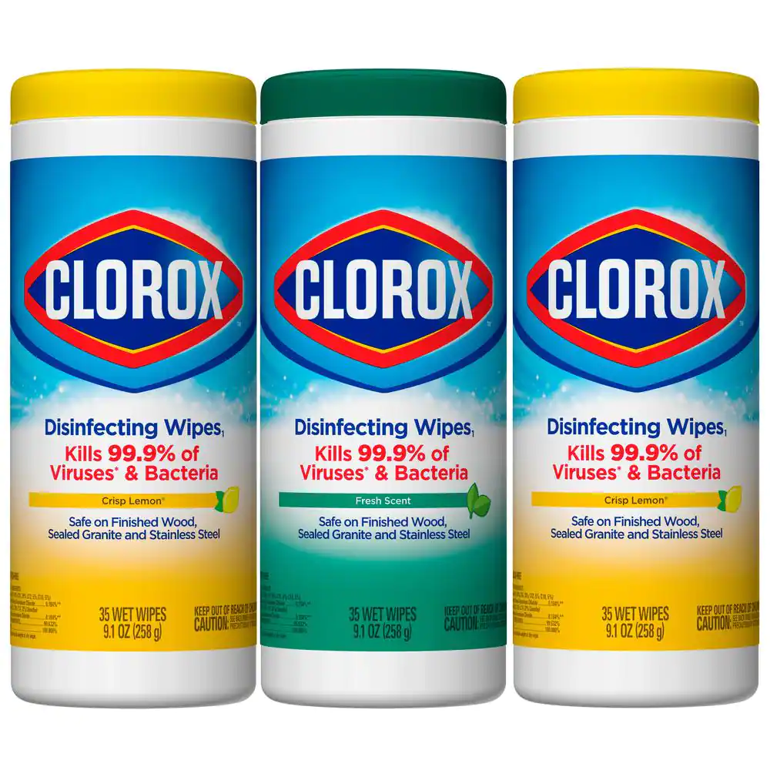 | 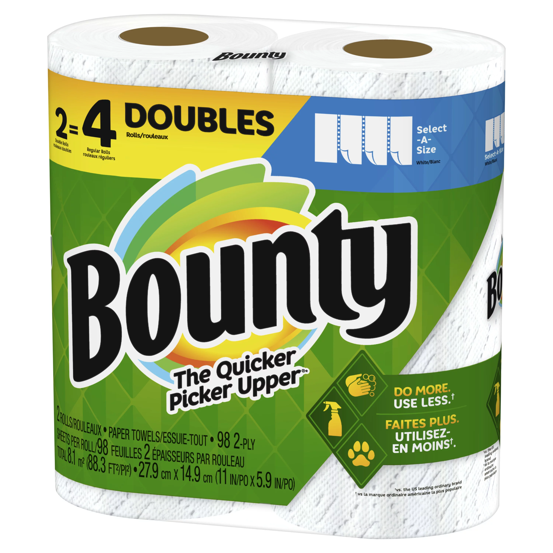 | 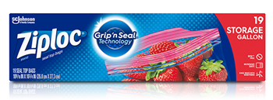  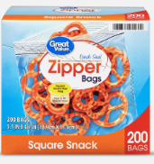 | 